**Department of Information Systems and Cyber Security University of Texas in San Antonio**



IS 3413: Telecom and Networking-001, Fall, 2022

Name: Daniel Cook  
UTSA ID: dhz799  
Email address: *danielwcook5@gmail.com*

Lab Assignment: Lab: M10 – MPLS Analysis  
Date Due: 11/5/2022  
Date Submitted: 11/5/2022

Section A, Question 1: Recall the discussion of multiprotocol label switching (MPLS) from the lecture slides. Highlight the first packet and examine the Packet Details pane. In what layer of the OSI model does the MPLS data reside? Explain your answer.

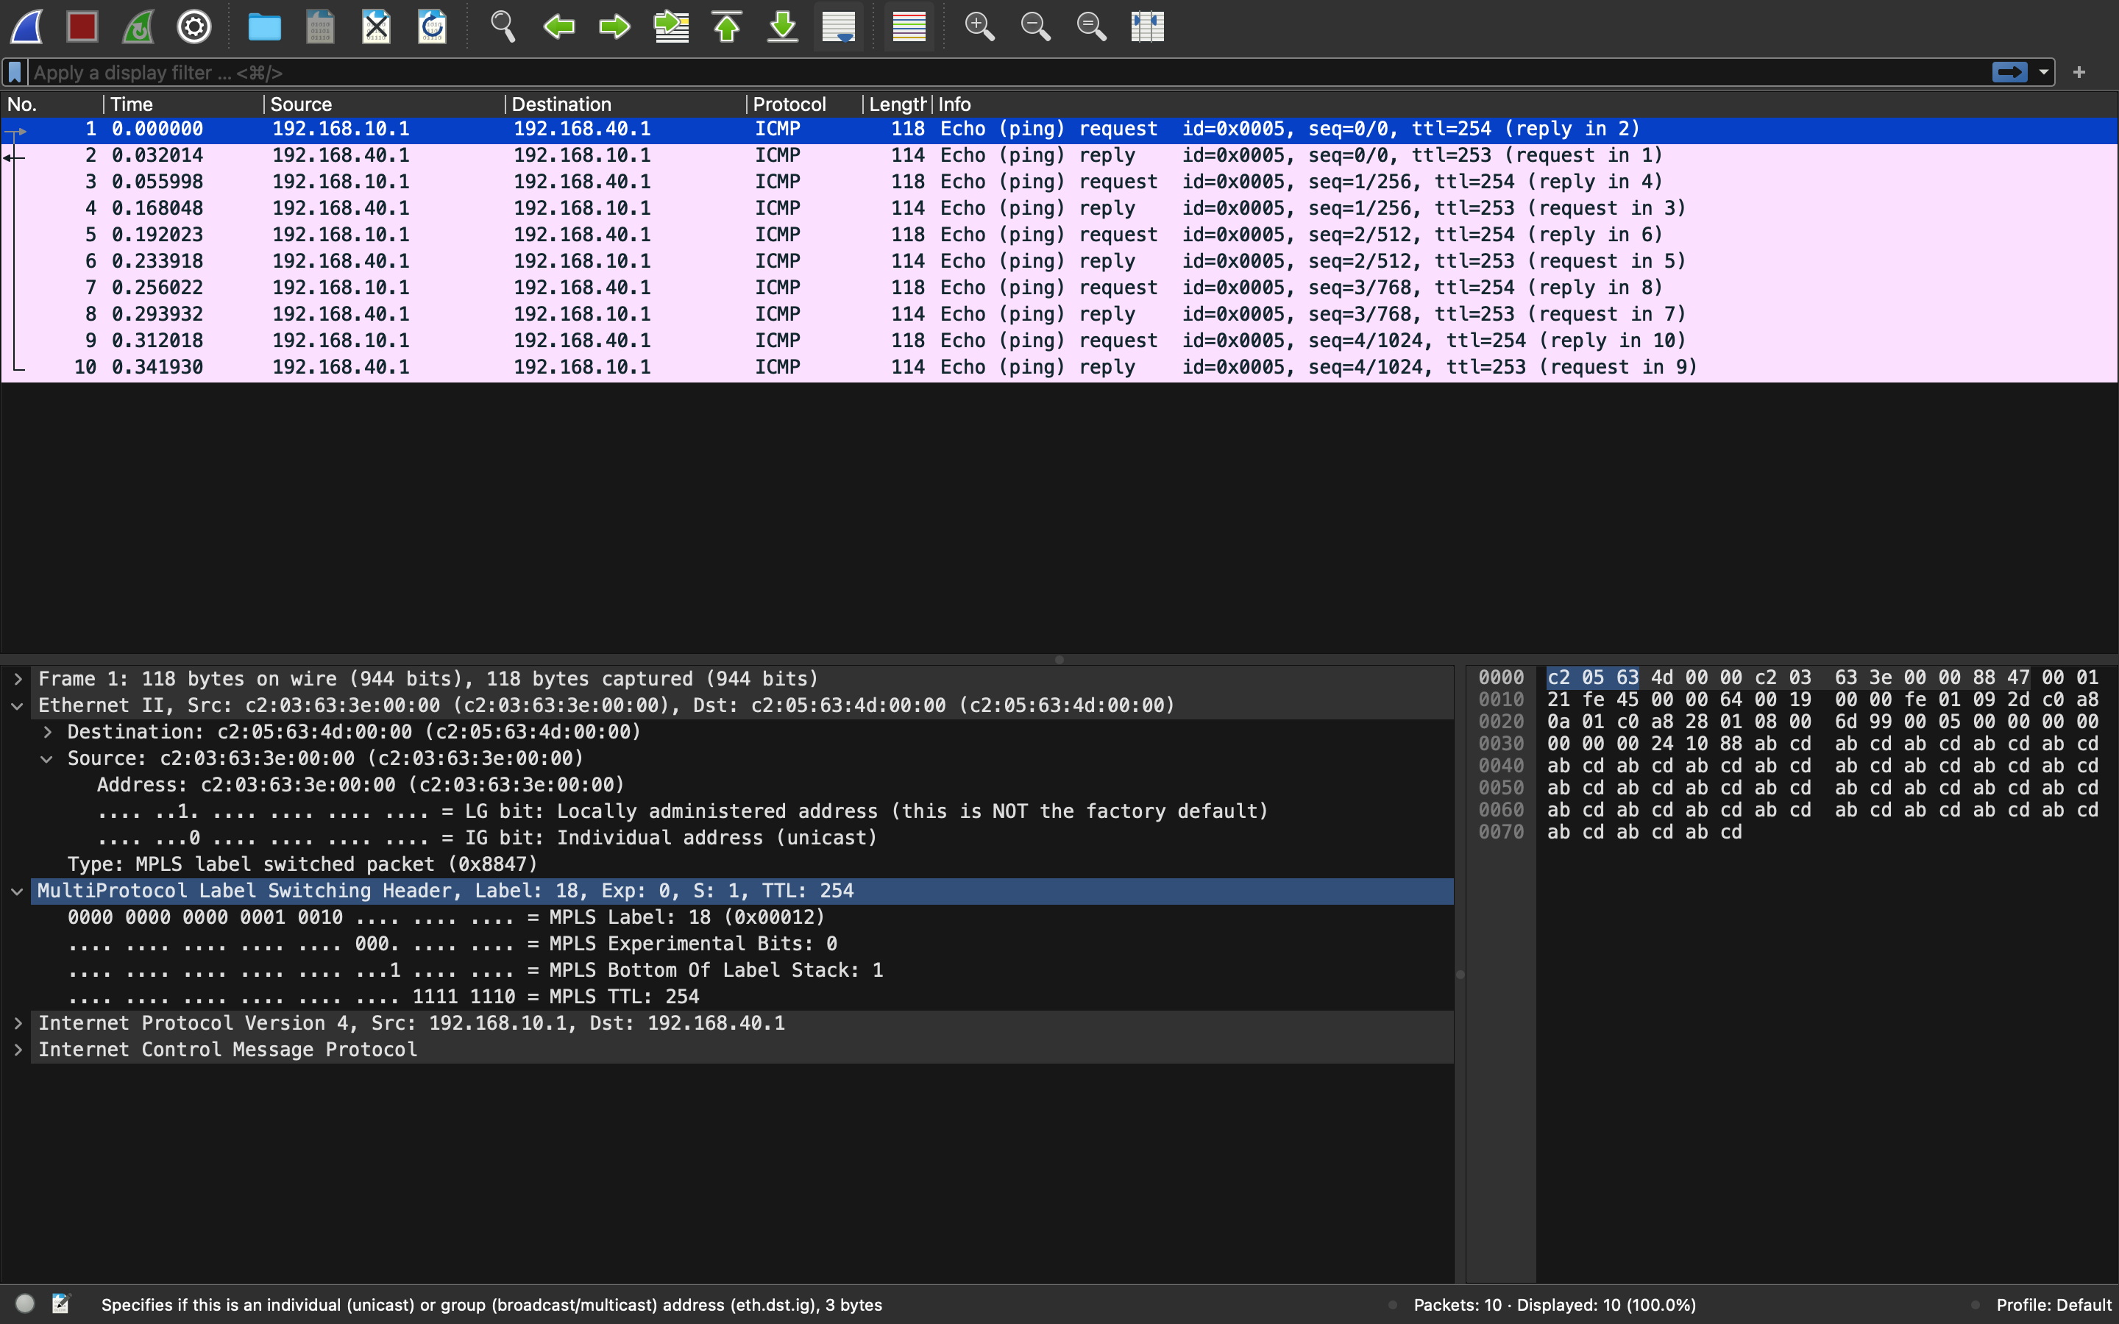

MPLS revolves around the second and third layer of the OSI model, Which are the Data link layer and Network Layer. Which is also known as 2.5 Layer.

Section A, Question 2: Assume that the first packet is being forwarded by an entry point router of an MPLS-based carrier network. Which piece of information, displayed in the Packet Details pane, is directly responsible for determining how the packet will be routed through the carrier network?



Layer 3 is the forwarding decision that is based off the IP addresses.

Section A, Question 3: A time-to-live (TTL) value is set as part of various routing protocols to ensure that a misrouted packet does not bounce around the network indefinitely. As a packet is processed at each router (i.e. – at each “hop”), the TTL value is reduced by one. If/when the TTL value reaches zero, the packet is dropped. How many “hops” between routers could the first packet make before it would be dropped?

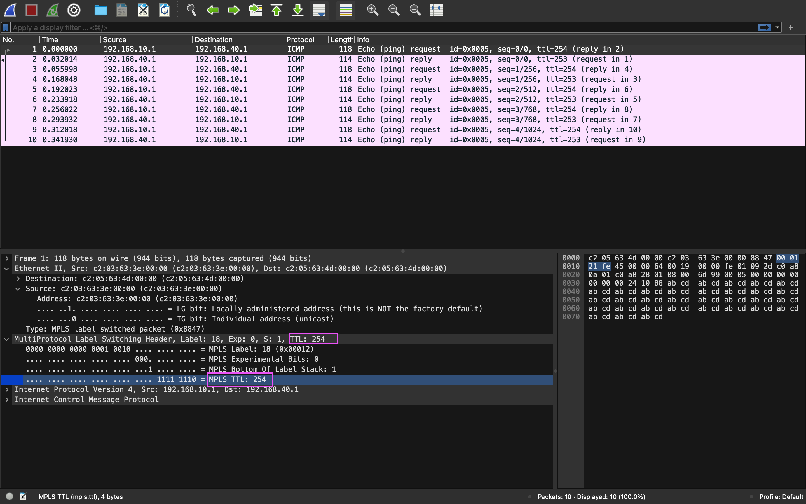

The TTL value is 254, so there will be 254 hops before getting dropped.